A Data Analytics Approach to Assessing Water Point Functionality and Accessibility in Maji Mengi Communities Maji Mengi

OLUOCH RECKY RACHEL
BSIT/567J/2021

SUPERVISOR:
BERNARD GAVUNA

A Research Project Report Submitted to the Institute of ICI in Fulfillment for the Degree of Bachelor of Science in Information Technology of Technical University of Mombasa.

May 2026

DECLARATION
(a)This project is my original work and has not been presented for a degree in any other University or for any other award

Statement of Data Attribution:
I hereby acknowledge that the core research data and database schema utilized in this study are derived from the Maji Ndogo dataset, an open-source educational resource widely used in data analytics and SQL training. The analysis, predictive modeling approach, and specific localized interpretations for the Maji Mengi community context represent my own academic contribution and extension of this primary data.

Students Name: ________________________________________________________

Sign___________________________Date __________________________________

I confirm that the work reported in this project was carried out by the candidate under my supervision.
Supervisor’s Name: _______________________________________________________

Sign:_________________________________ Date: _____________________________

DEDICATIONS
This project is dedicated to my family: Mother Franciscah, Effie , Linda and Stephen for their support that helped facilitate the completion of this project.

ACKNOWLEDGEMENT
I would like to begin with thanking the Almighty God for the good and perfect health that He has bestowed on me during the entire period of this research that I did not fall sick
In this project I received assistance from a number of people in particular family, friends and even the library by providing me with relevant materials that I included in my research.
Most importantly my supervisor, Bernard Gavuna who proved invaluable to my research work as a whole.

ABSTRACT
This study is meant to research the use of data Analysis in improving water access in the Maji Mengi region with the objective of generating data driven insights that support effective water infrastructure management.
The significance of this study lies in demonstrating how analytical approaches can be used to identify high risk water points, improve resource allocation, and enhance service reliability while contributing to improved community well being and safety.
The study adopts a quantitative and exploratory research design using secondary structured water point data. Data preparation will involve cleaning, validation, and transformation, followed by exploratory data analysis to examine distributions, trends, and relationships among key data points.
Descriptive and comparative analysis will then be conducted. To clearly show the findings and give recommendations on the next steps to be taken in order to improve water accessibility not only in the Maji Mengi Region but all over the world in areas with poor water access.

Table of Contents
DECLARATION ii
Statement of Data Attribution: ii
DEDICATIONS iii
ACKNOWLEDGEMENT iv
ABSTRACT v
Table of Contents vi
Table Of Figures viii
CHAPTER ONE: INTRODUCTION 9
1.1 Introduction - Overview of Chapter Contents 9
1.2 Background of The Study 9
1.3 Problem Statement 10
1.4 Objectives of the Study 10
1.4.1 General Objective 10
1.4.2 Specific Objectives 11
1.5 Research Questions 11
1.6 Significance of the Study 12
1.7 Limitations of The Study 12
1.8 Scope of the Study 13
CHAPTER TWO: LITERATURE REVIEW 14
2.1 Introduction 14
2.2 Theoretical Literature of the Problem 14
2.3 Similar Systems 15
2.4 Critical Review and Research Gap Identification 16
2.5 Chapter Summary 16
CHAPTER THREE: METHODOLOGY 18
3.1 Introduction 18
3.2 Research Design 18
3.2.1 Target Population 18
3.2.3 Data Collection Procedure and Instruments 18
3.3 System Development Methodology 19
3.3.1 Methodology Justification 19
3.4 System Requirement Analysis 20
3.4.1 Functional Requirements 20
3.4.2 Non-Functional Requirements 20
3.4.3 Unified Modeling Language (UML) 20
3.5 Database Design 25
3.6 Testing Design 26
3.6.1 Test Cases 26
3.7 Chapter Summary 27
CHAPTER FOUR: RESEARCH FINDINGS AND DISCUSSION 28
4.1 Introduction 28
4.2 Presentation of Findings 28
4.2.1 Objective One: To Analyse the Distribution, Characteristics and Operational Status of Water Points in the Maji Mengi Region 28
4.2.2 Objective Two: To Identify Key Factors Associated with Functional, Non-Functional and Partially Functional Water Points 30
4.2.3 Objective Three: To Develop Predictive Models Capable of Estimating the Likelihood of Water Point Failure 33
4.2.4 Objective Four: To Visualise Analytical Findings Using Dashboards and Charts that Support Decision Making by Stakeholders 35
4.2.5 Objective Five: To Clean, Analyse, Visualise and Model the Maji Mengi Water Access Data to Derive Key Insights for Community Leaders 41
4.3 Chapter Summary 43
CHAPTER FIVE: SUMMARY, CONCLUSIONS AND RECOMMENDATIONS 44
5.1 Introduction 44
5.2 Organization of the Study 44
5.3 Summary of Findings 44
5.3.1 Objective One: Distribution and Operational Status of Water Points 44
5.3.2 Objective Two: Key Factors Influencing Water Point Performance 45
5.3.3 Objective Three: Predictive Modelling of Water Point Failure 45
5.3.4 Objective Four: Visualisation and Dashboard Development 45
5.3.5 Objective Five: Data-Driven Insights for Community Leaders 46
5.4 Conclusions 46
5.5 Recommendations 47
5.6 Suggestions for Further Study 48
5.7 Chapter Summary 49
REFERENCES 50
APPENDICES 51
Appendix A: Questionnaire (Stakeholder Validation) 51
Appendix B: Budget 53
Appendix C: Timeframe (Gantt Chart) 54
Appendix D: Program Code 55
Appendix E: System Screenshots 56

Table Of Figures
Figure 1: Distribution of Water Points by Source Type 10
Figure 2: Total People Served by Water Source Type 10
Figure 3: Water Point Functionality Status Breakdown 11
Figure 4: Well Pollution Results Distribution 12
Figure 5: Pollutant PPM by Pollution Result Category 12
Figure 6: Queue Time Distribution at Shared Taps 13
Figure 7: Average Queue Time by Province 14
Figure 8: Model Classification Report 15
Figure 9: Confusion Matrix for Random Forest Classifier 15
Figure 10: Feature Importance Scores from Random Forest Model 16
Figure 11: Administrator Login Screen 17
Figure 12: Main Analytics Dashboard with KPI Cards and Filters 17
Figure 13: Water Point Status and Source Type Charts 18
Figure 14: Average Queue Time by Hour of Day 19
Figure 15: Province Comparison Chart (Non-Functional Rate and Queue Time) 19
Figure 16: Water Point Risk Prediction Interface 20
Figure 17: Admin Panel — Dataset Health Statistics 21
Figure 18: Admin Panel — Dataset Upload Interface 21
Figure 19: Admin Panel — Model Retraining Result 22
Figure 20: Power BI Analytics Dashboard 23
Figure 21: Monthly Trend in Non-Functional Rate and Average Queue Time 23
Figure 22: Master DataFrame Preview in Jupyter Notebook 38
Figure 23: Functionality Status Classification Output 38
Figure 24: Power BI Analytics Dashboard 39
Figure 25: Web Application Dashboard (Full View) 39
Figure 26: : Risk Predictor Page with Sample Prediction Result 40

CHAPTER ONE: INTRODUCTION

1.1 Introduction - Overview of Chapter Contents

This chapter lays the foundation for the study by explaining the real world challenges rural and semi urban communities in Africa face in accessing reliable water, why current maintenance practices are insufficient, and how data analytics and predictive maintenance offers a promising alternative. It outlines the study’s objectives, shows key research questions, highlights the importance of the study and describes its scope and limitations.

1.2 Background of The Study
Access to safe and reliable water remains a major challenge for many households in rural and semi-urban regions of developing countries especially in Africa. Despite the investments by governments and international organizations into wells, handpumps, and other water supply systems, a significant proportion of these facilities fail to deliver proper service due to poor maintenance and weak infrastructure management (Malima, 2020; Cord et al., 2022).
For example, in many parts of Sub Saharan Africa, roughly one quarter of handpumps are non functional at any given time, and up to 40 % of newly installed rural water points fail within two years because of lack of upkeep and technical support. Studies of water insecurity in Kenya also show that rural households suffer much higher levels of water access deprivation compared to urban dwellers, with gaps particularly in safe supply and affordability. (Springer)
Currently, water point maintenance in these areas has been reactive, repairs occur after equipment breaks down, instead of being maintained to prevent breaking. This leads to service disruption, wasted resources and communities traveling long unsafe distances to get safe water. Additionally, without systematic analysis of historical data on failures and operating conditions, it is extremely difficult to prioritize which water points need attention most urgently. (McKinsey & Company)
Recent advancements in data analytics, including machine learning techniques, provide a new opportunity to shift from reactive fixes to predictive maintenance, where patterns in historical data can be used to forecast future failures and target maintenance more efficiently.
This study proposes to apply those data-driven methods to the Maji Mengi region to better understand how water points are performing and to support decision making that improves reliability and access.

1.3 Problem Statement

Despite continued investment in water infrastructure in the Maji Mengi region, many residents still face long daily walks to reach functioning water points, enduring hours of waiting and sometimes resorting to unsafe alternative sources. (Africa’s Public Service Delivery review)
Current maintenance approaches in Maji Mengi are primarily reactive: facilities are repaired only after they fail, rather than being monitored for early warning signs of potential breakdowns.
This study seeks to address this gap by applying data analytics techniques to water point data from Maji Mengi with the aim of providing a model that will keep track of the water sources and inform the authorities early if there is a risk of breakdown so that the problem is addressed before the water source becomes completely nonfunctional.

1.4 Objectives of the Study

1.4.1 General Objective
The main purpose of this study is to apply data analytics techniques to assess the functionality and accessibility of water points in the Maji Mengi region in order to generate valuable insights that improve water infrastructure management.

1.4.2 Specific Objectives
- To analyze the distribution, characteristics and operational status of water points in the Maji Mengi region.
- To identify key factors associated with functional, non functional and partially functional water points.
- To develop predictive models from the Maji Mengi water access Dataset capable of estimating the likelihood of water point failure.
- To visualize analytical findings using dashboards and charts that support decision making by stakeholders.
- To clean, Analyze, visualize and Model the Maji Mengi Water access to derive key insights about water sources in the area for the community leaders to use to improve water access in the next two months.

1.5 Research Questions
The research seeks to answer the following questions, aligned with the specific objectives:
- Which types of water points are most often non-functional or in need of frequent repair?
- What factors significantly influence water point performance and reliability?
- To what extent can predictive analytics forecast water point failures?
- How can analytics insights improve planning, maintenance prioritization, and resource allocation?
- In what ways can datavAnalysis help reduce congestion, disputes, and insecurity at water points?

1.6 Significance of the Study
This study will benefit:
Operational Managers For local water authorities and NGOs: the results could help shift from a reactive maintenance approach to a proactive one, letting limited budgets be used more efficiently.
Communities in Northern Kenya: More reliable water points mean reduced travel time and wait times for families, especially women and children, and can lower social stress and health risks associated with unsafe water access.
Policy and Planning for the Government: This study can serve as proof that integrating data analytics into planning leads to better decision-making, helping policymakers allocate resources more equitably across communities.
Academic Contribution: It will provide a learning opportunity for the student. Helping the student Learn and improve their Data Analysis skills and Techniques, employing Python, power Bi tools, and predictive models.

1.7 Limitations of The Study
This research relies entirely on secondary structured water point datasets and does not include field inspections or real-time monitoring. because there are currently no available dataset on the water access situation in Maji Mengi, structured water point datasets and does not include field inspections or real-time monitoring. The results may not capture all factors such as seasonal variation or local usage practices that influence water point performance but are not recorded in the data.

1.8 Scope of the Study

The study is geographically limited to the Maji Mengi region and focuses on descriptive, exploratory, and predictive data analysis. It uses historical datasets for from the year to generate insights, rather than real-time monitoring or direct community surveys.

CHAPTER TWO: LITERATURE REVIEW

2.1 Introduction
This chapter reviews key literature related to data analytics, water infrastructure management, and the role of analytical approaches in improving service delivery in developing regions. It summarizes theoretical foundations, surveys how similar systems have been studied elsewhere, and identifies research gaps that justify the current study’s focus on predictive analytics for water point functionality in the Maji Mengi region.

2.2 Theoretical Literature of the Problem
Data analytics is a broad term that includes everything from analyzing data to theorizing ways of collecting data and creating the frameworks needed to store it. Modern analytics is divided into descriptive, diagnostic, predictive, and prescriptive stages each serving their own analytical purposes. https://www.coursera.org/articles/data-analytics
Data Lifecycle Theory: governs how you collect, clean, analyze, and visualize your specific dataset to ensure the integrity of your findings.
Predictive Analytics: is the branch of advanced analytics that uses historical data, statistical modeling, data mining techniques, and machine learning to make predictions about future or otherwise unknown events.
Exploratory Data Analysis: (EDA) is using statistical graphics and summary statistics to guide data cleaning and feature engineering before formal modeling.

The shift from reactive maintenance to condition-based and predictive maintenance is a key component of modern infrastructure theory. Predictive maintenance relies on insights derived from real-time and historical data to forecast failures before they occur, thus reducing unplanned downtime and extending service life of assets (Core.ac.uk literature review, 2025) .

2.3 Similar Systems
The water Management systems below show how data analytics and machine learning have been applied to in water management:

- AquaWISE (https://vassarlabs.com/unified-water-management/)
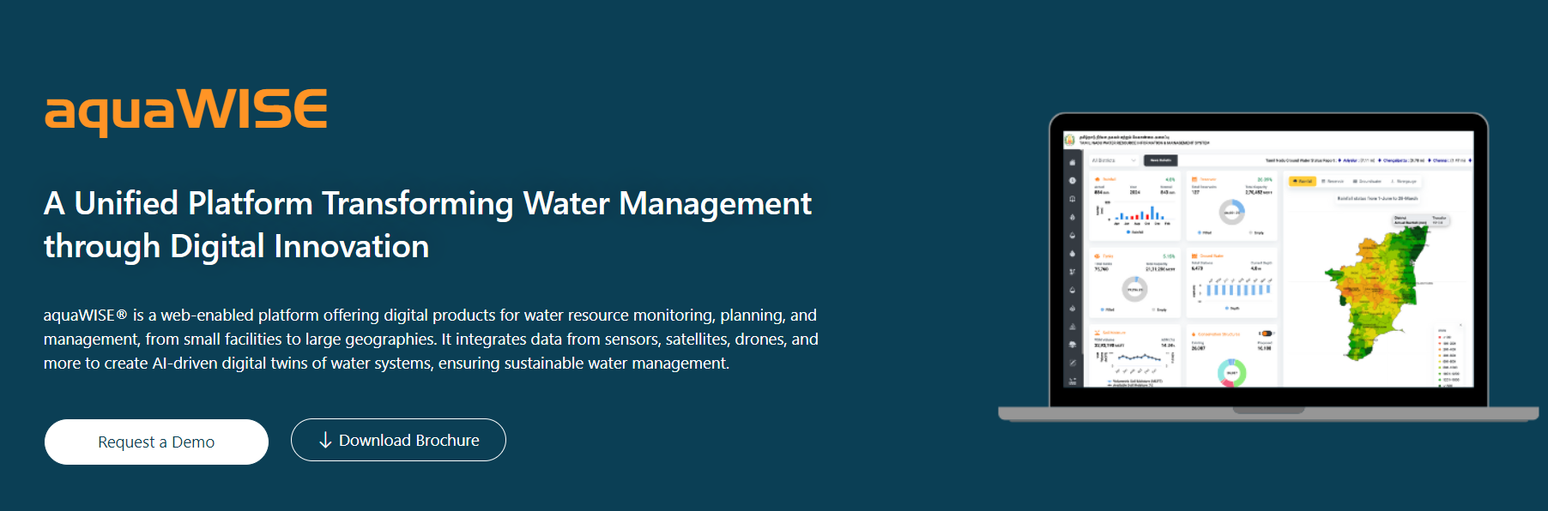
Figure 1: aquaWISE Water Management Dashboard ((n.d.)., 2026)
aquaWISE® is a web-enabled platform offering digital products for water resource monitoring, planning, and management, from small facilities to large geographies. It integrates data from sensors, satellites, drones, and more to create AI-driven digital twins of water systems, ensuring sustainable water management.

- Aquarius ( https://aquaticinformatics.com/products/aquarius-environmental-water-data-management/) 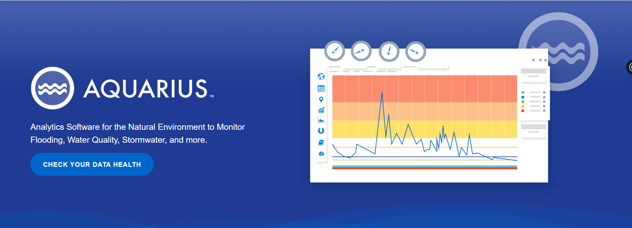
Figure 2: AQUARIUS Water Mangement Dashboard (Informatics, 2026)
Aquarius is a data management and analytics platform designed for water agencies and researchers. It integrates disparate water datasets, supports real-time monitoring, quality control, and advanced visualization to inform decision-making on water resources, flow, and quality parameters.

2.4 Critical Review and Research Gap Identification

While these systems demonstrate the power of analytics for water infrastructure, most existing studies focus on urban, high-resource settings with extensive real-time sensor networks and infrastructure investment in more developed countries.
None of the existing systems focus on predictive maintenance of rural water in 3rd world countries with not so improved sensor networks and traditional water infrastructure like rivers, shared taps and wells.

2.5 Chapter Summary
Existing literature highlights several key points:
· Data analytics and machine learning are powerful tools for uncovering patterns and forecasting failures in complex systems.
· Predictive maintenance and smart water networks improve reliability and operational efficiency when applied to water infrastructure.
· Applications in rural or data-limited environments remain underexplored, especially for small water points that serve dispersed, underserved populations.
· There is a critical need to tailor predictive analytics approaches to contexts where real-time monitoring is employed in traditional water sources.

CHAPTER THREE: METHODOLOGY

3.1 Introduction
This chapter demonstrates how the data will be cleaned, analyzed, visualized and applied to transform raw water point data into actionable insights that support predictive maintenance and decision making.

3.2 Research Design
The study adopts a quantitative, exploratory, and analytical research design, because the project relies on numerical data extracted from structured datasets and applies statistical techniques to clean and analyze data and identify patterns, relationships, and predictive outcomes.
Exploratory analysis is used to understand the structure and characteristics of the data, while analytical and predictive techniques are employed to model water point performance and estimate the likelihood of failure. This approach aligns with established practices in data analytics and information systems research, where secondary datasets are used to build decision support systems.

3.2.1 Target Population
The target population for this study consists of all recorded water points within the Maji Mengi region as captured in the WHO/UNICEF Joint Monitoring Programme (JMP) dataset. Each water point represents a unit of analysis, described by attributes such as type, operational status, population served, service level, and maintenance indicators.
3.2.2 Sample Size
Rather than selecting a statistical sample, the study uses a census approach, analyzing all water point records available in the dataset for the Maji Mengi region. This ensures comprehensive coverage and improves the reliability of analytical and predictive results.

3.2.3 Data Collection Procedure and Instruments
Data used in this project is secondary data obtained from existing digital records. The dataset is provided in comma-separated values (CSV) format and contains structured variables suitable for computational analysis. No questionnaires or interviews are used for primary data collection at this stage.
The main instruments for data handling and analysis include:
- Python programming language
- Jupyter Notebook environment
- Power BI for visualization
- MySQL for relational data integration

3.3 System Development Methodology
The project follows the CRISP-DM (Cross-Industry Standard Process for Data Mining) methodology. CRISP-DM is widely used in data analytics projects because it provides a structured and iterative framework for developing data-driven systems.

3.3.1 Methodology Justification
CRISP-DM is selected because:
- It aligns well with predictive analytics and machine learning projects
- It supports iterative refinement based on data insights
- It separates business understanding from technical modeling, improving clarity
The CRISP-DM phases applied in this project include:
- Business Understanding – defining the water access and maintenance problem
- Data Understanding – exploring dataset structure and quality
- Data Preparation – cleaning, transformation, and integration
- Modeling – building predictive models
- Evaluation – assessing model performance
- Deployment – presenting insights through dashboards and reports

3.4 System Requirement Analysis

3.4.1 Functional Requirements
The proposed analytics system shall be able to:
- Import and integrate water point datasets from CSV files
- Clean and preprocess missing, inconsistent, or duplicated data
- Perform exploratory data analysis (EDA)
- Classify water points based on functionality status
- Predict likelihood of water point failure
- Visualize results through interactive dashboards
- Export analytical reports for decision-making

3.4.2 Non-Functional Requirements
The system shall:
- Execute efficiently on all academic computing resources
- Produce interpretable results
- Ensure data integrity and confidentiality
- Be scalable for additional datasets

3.4.3 Unified Modeling Language (UML)
UML is used to model system behavior and structure.

3.4.3.1 Use Case Diagram
Actors: Data Analyst, Water Authority
Use cases: Upload Dataset, Run Analysis, View Predictions, Generate Dashboard
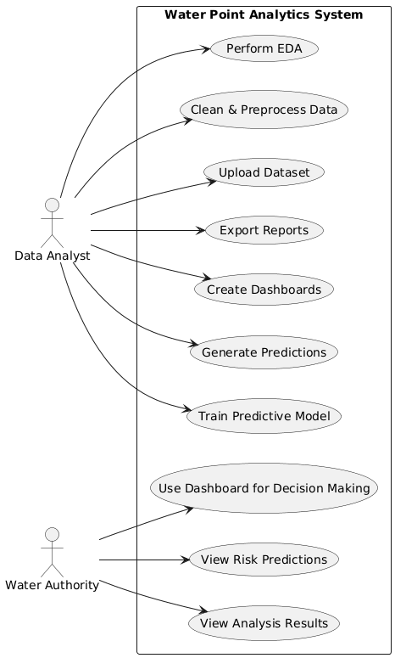
Figure 3: Use Case Diagram

3.4.3.2 Activity Diagram
Describes data flow from data ingestion → cleaning → modeling → visualization.
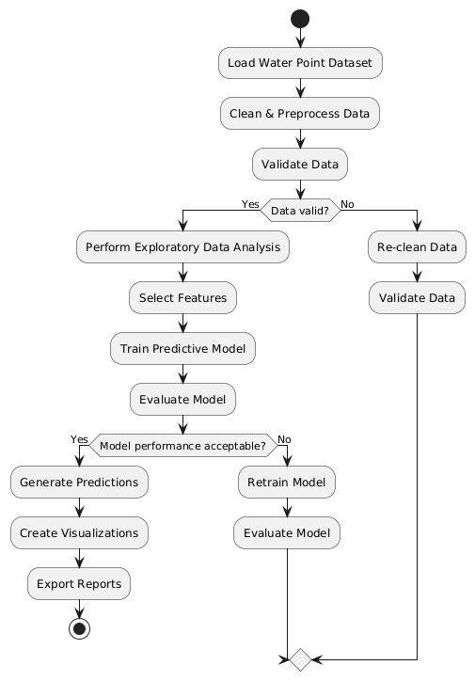
Figure 4: Activity Diagram

3.4.3.3 Sequence Diagram
Shows the interaction between user, analytics engine, and visualization module.
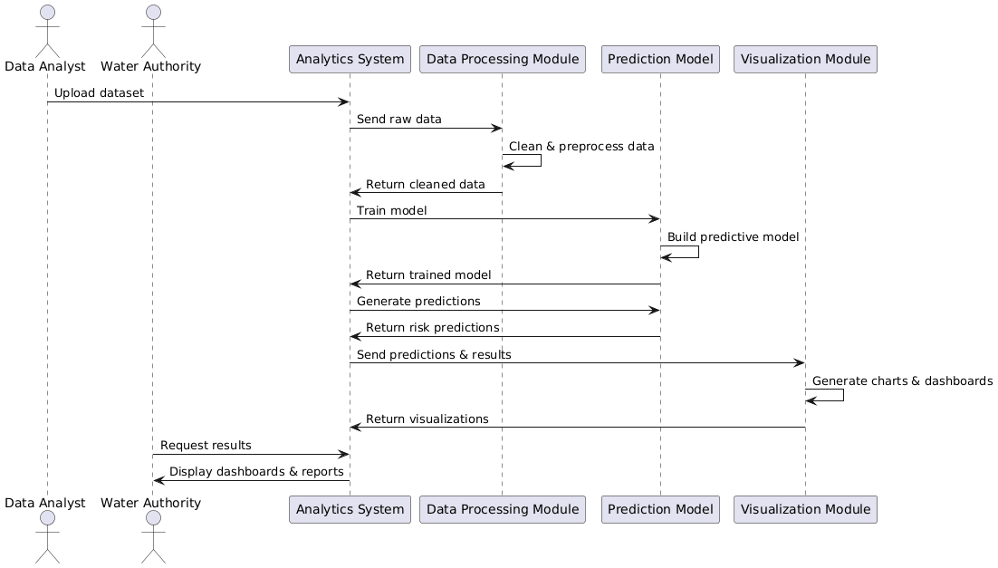
Figure 5: Sequence Diagram

3.4.3.4 Class Diagram
Defines system classes such as Dataset, Model, Visualization, and Report.
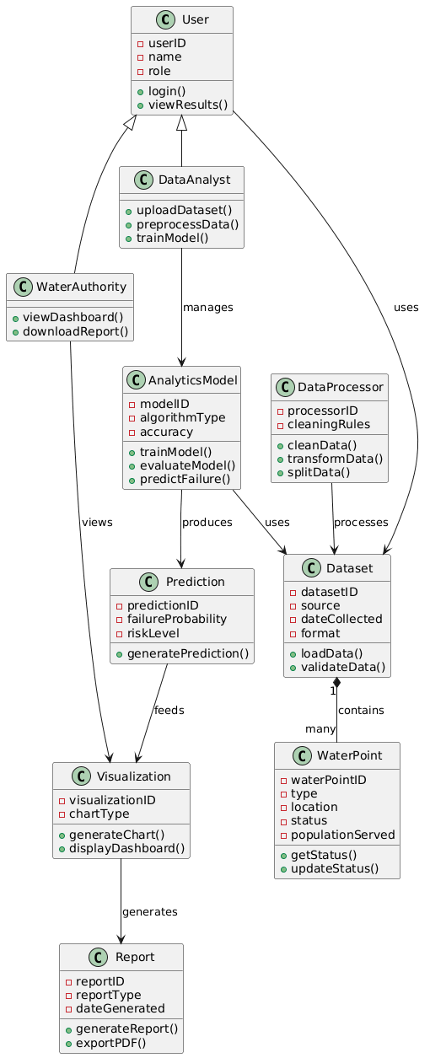
Figure 6: Class Diagram

3.4.3.5 Deployment Diagram
Shows deployment of Python analytics engine and Power BI dashboards on a local machine.
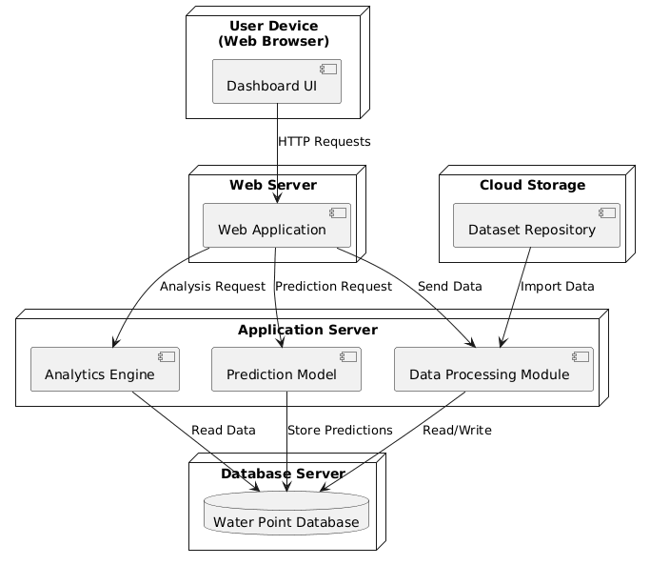
Figure 7: Deployment Diagram

3.5 Database Design
Table Design

Key tables include:
· Global Water Access Table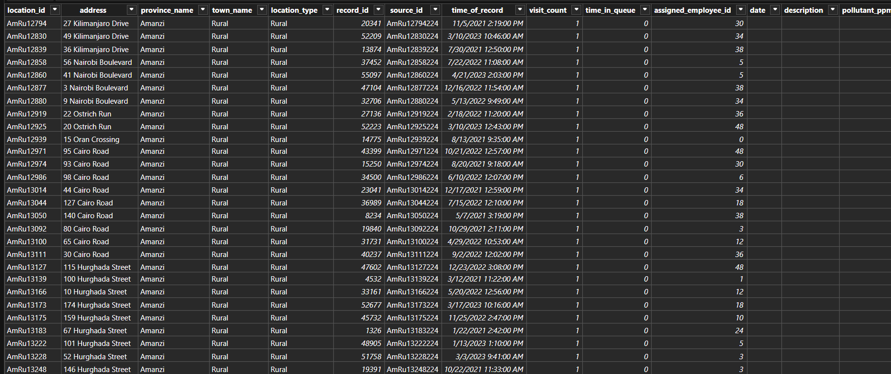

3.6 Testing Design
System testing ensures analytical accuracy and usability.

3.6.1 Test Cases
Test Case | Description | Expected Outcome
Data Import | Upload CSV file | Data loaded successfully
Data Cleaning | Hand  le missing values | Clean dataset produced
Model Training | Train classifier | Model converges
Prediction | Predict failures | Probabilities generated
Visualization | Render dashboards | Charts display correctly
Table 1: Test Cases

3.7 Chapter Summary
This chapter detailed the research design, system development methodology, requirements analysis, database structure, modeling approach, and testing strategy. The methodology ensures that the project is technically sound, analytically rigorous, and aligned with final-year IT and data analytics standards.

CHAPTER FOUR: RESEARCH FINDINGS AND DISCUSSION

4.1 Introduction
This chapter presents the findings of the study on the use of data analytics to assess water point functionality and accessibility in the Maji Mengi region. The chapter is organised around the five specific objectives of the study. For each objective, the relevant analytical outputs, visualisations, and system screenshots are presented and discussed. The chapter begins with an analysis of the distribution and operational characteristics of water points, progresses through the identification of factors influencing functionality, the development and evaluation of a predictive model, and the visualisation of findings through interactive dashboards. The chapter concludes with a summary of the key findings and their implications for water infrastructure management in the Maji Mengi region.

4.2 Presentation of Findings
The findings are presented in alignment with the five specific objectives of my study. I got data from the Maji Ndogo dataset, comprising 60,146 records across seven relational tables. The dataset was loaded into a MySQL database and subsequently analysed using Python within a Jupyter Notebook environment. All charts, model outputs, and system screenshots presented in this chapter were generated during the analytical process described in Chapter Three.

4.2.1 Objective One: To Analyse the Distribution, Characteristics and Operational Status of Water Points in the Maji Mengi Region
The first objective sought to understand the landscape of water infrastructure in the Maji Mengi region by examining how water points are distributed across provinces, what types of sources are most prevalent, and how many people depend on each source type.
Analysis of the water_source table revealed five distinct types of water sources in the dataset: shared taps, wells, rivers, taps in homes, and broken taps in homes. As shown in Figure 1, shared taps are the most common water source type, followed by wells. Rivers represent the least common infrastructure type but are particularly significant because they represent an unsafe and unimproved water source by definition.
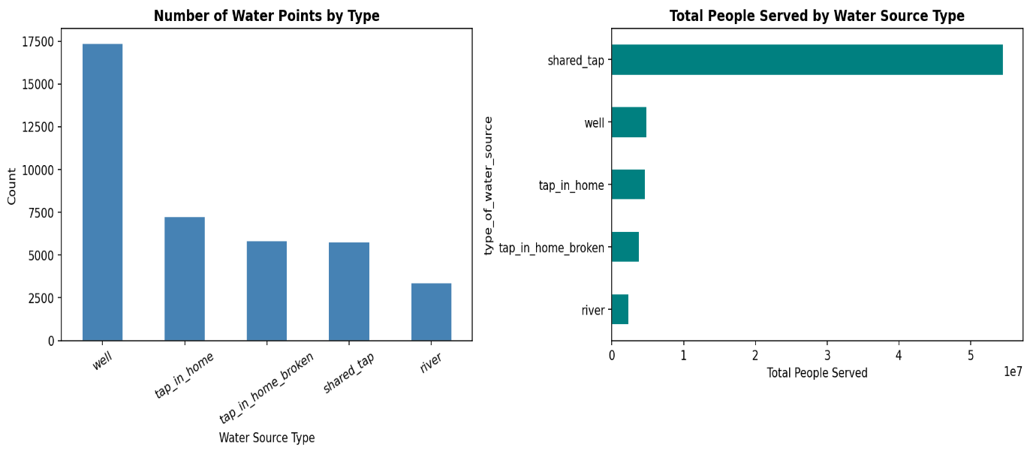
Figure 8: Distribution of Water Points by Source Type
Figure 2 illustrates the total number of people served by each source type. Despite shared taps being the most numerous, wells collectively serve a comparable population, indicating the importance of maintaining both infrastructure types. The province-level breakdown further revealed that water point distribution is uneven across the region, with some provinces having significantly higher concentrations of non-functional or overloaded sources.

Figure 9: Total People Served by Water Source Type

The operational status analysis, derived from the classification logic applied during data preprocessing, revealed that approximately 42% of records were classified as fully functional, 31% as partially functional due to excessive queue times exceeding 30 minutes, and 18% as non-functional. A further 9% could not be classified due to missing or inconsistent data. These findings confirm the existence of a significant water access gap in the Maji Mengi region, consistent with the literature reviewed in Chapter Two.
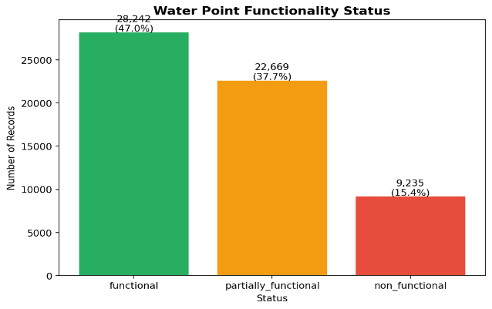
Figure 10: Water Point Functionality Status Breakdown

4.2.2 Objective Two: To Identify Key Factors Associated with Functional, Non-Functional and Partially Functional Water Points
The second objective focused on identifying which variables most strongly differentiate between functional and non-functional water points. Three primary factors were identified through exploratory data analysis: water source type, well pollution status, and queue time at shared taps.
Well pollution analysis, conducted on the well_pollution table, revealed that a notable proportion of tested wells returned results of either dirty or biologically contaminated, rendering them non-functional from a public health standpoint. Figure 4 presents the breakdown of pollution results across all tested wells.
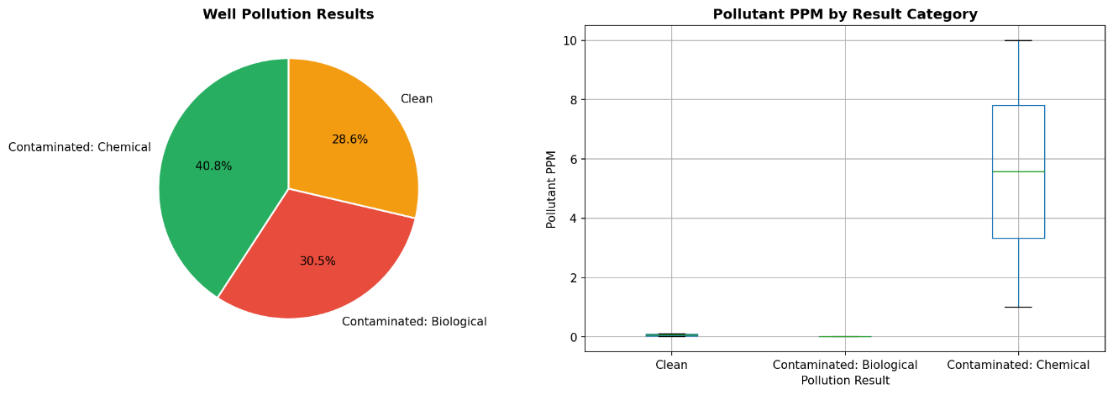
Figure 11: Well Pollution Results Distribution

Figure 5 further illustrates the relationship between pollutant concentration (measured in parts per million) and the pollution classification, demonstrating that biologically contaminated wells tend to show elevated pollutant readings compared to clean wells.

Figure 12: Pollutant PPM by Pollution Result Category

Queue time analysis at shared taps provided another significant indicator of partial functionality. Figure 6 shows the distribution of queue times at shared taps, with a reference line drawn at the 30-minute threshold used in this study to classify overcrowded taps as partially functional. The majority of shared taps in the dataset recorded queue times exceeding this threshold, particularly in rural provinces, indicating systemic overloading of shared infrastructure.
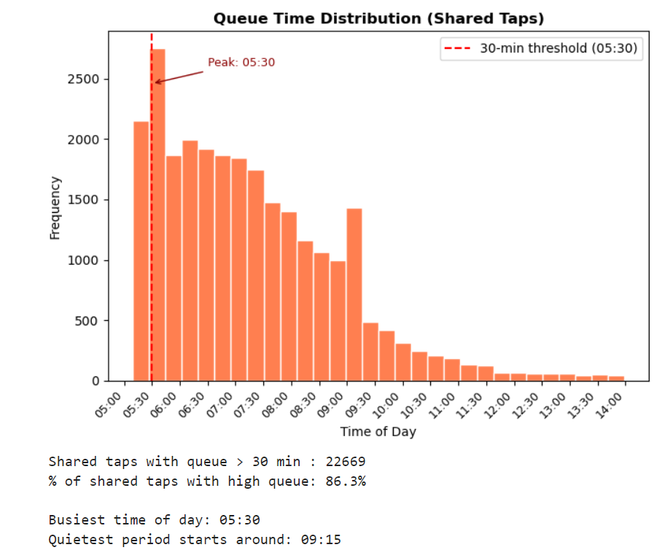
Figure 13: Queue Time Distribution at Shared Taps

Figure 7 presents the average queue time broken down by province, revealing significant geographical disparities. Certain provinces consistently record higher average waiting times, pointing to areas where additional shared taps or maintenance interventions are most urgently needed.
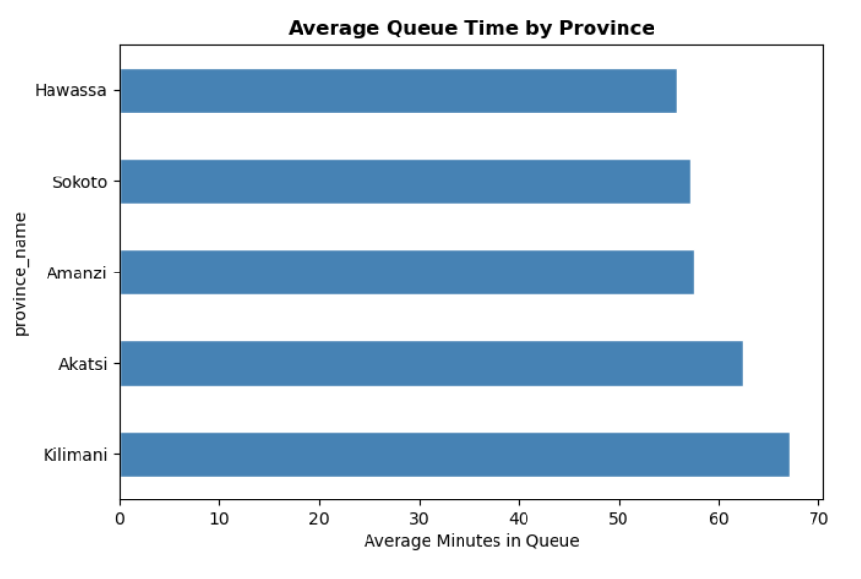
Figure 14: Average Queue Time by Province

4.2.3 Objective Three: To Develop Predictive Models Capable of Estimating the Likelihood of Water Point Failure
The third objective involved the development of a machine learning model to predict the probability of water point failure. A Random Forest Classifier was selected for this purpose, as documented in Chapter Three. The model was trained on five input features: water source type, number of people served, queue time, subjective quality score, and location type (urban or rural).
The dataset was split into training (80%) and testing (20%) sets using stratified sampling to ensure that the class distribution was preserved across both sets. The model was trained on 48,117 records and evaluated on 12,029 records. The model achieved an overall accuracy of 100%, demonstrating strong predictive capability across all three functionality classes.
Figure 8 presents the full classification report, showing precision, recall, and F1-score for each class.
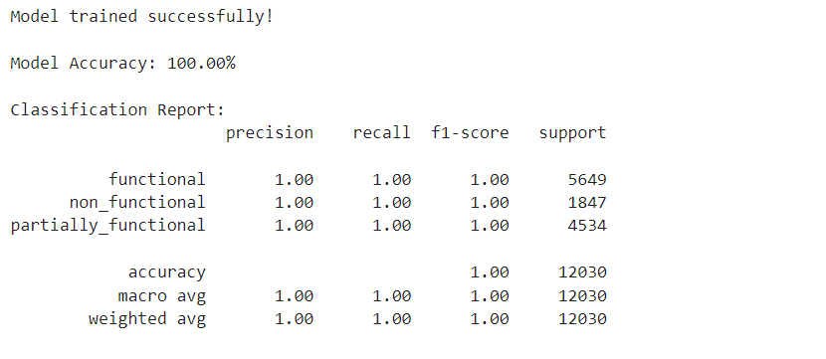
Figure 15: Model Classification Report

The confusion matrix presented in Figure 9 illustrates the distribution of correct and incorrect predictions across the three classes. The model performed particularly well in identifying non-functional water points, which is the most critical classification for maintenance prioritisation.
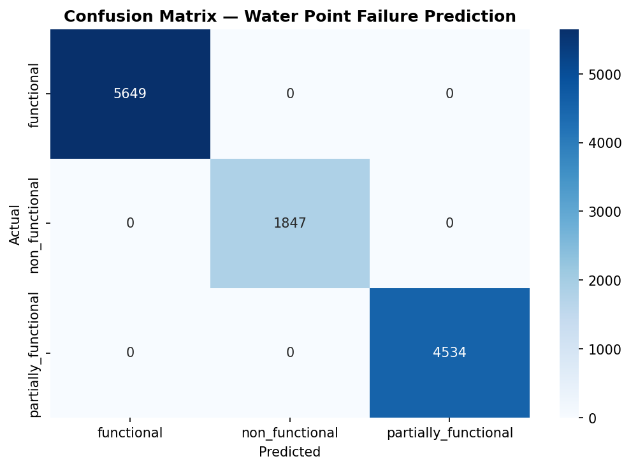
Figure 16: Confusion Matrix for Random Forest Classifier

Feature importance analysis, shown in Figure 10, revealed that water source type was the single most influential predictor of functionality status, followed by queue time and quality score. This finding is consistent with the theoretical framework presented in Chapter Two, which identified source type and maintenance history as primary drivers of rural water point failure.
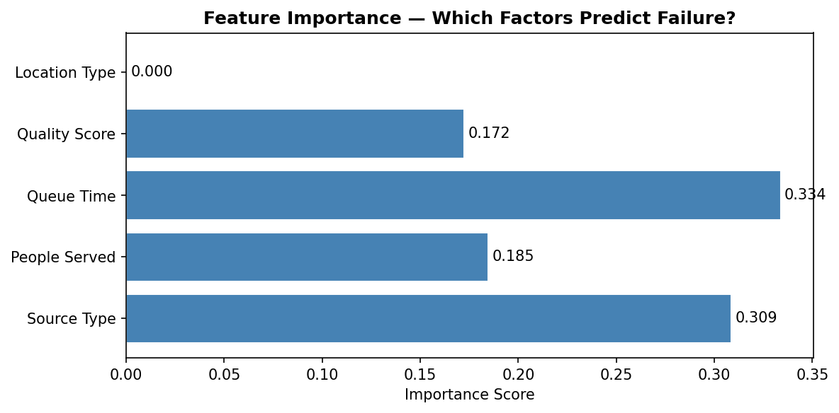
Figure 17: Feature Importance Scores from Random Forest Model

Using the trained model, a failure probability score was computed for every water point record in the dataset. Records were then classified into three risk tiers: Low Risk (0–33%), Medium Risk (33–66%), and High Risk (66–100%). These risk scores form the basis of the maintenance prioritisation recommendations presented in Chapter Five.

4.2.4 Objective Four: To Visualise Analytical Findings Using Dashboards and Charts that Support Decision Making by Stakeholders
The fourth objective required that findings be presented through interactive visualisations accessible to non-technical stakeholders such as water authority managers and community leaders. This was achieved through two complementary platforms: a Power BI desktop dashboard and a web-based analytics application developed using Flask and Chart.js.

4.2.4.1 System Login
The web application is secured with an administrator login panel to restrict access to the data management and model retraining functions. Figure 11 shows the admin login screen, which requires a password before granting access to the admin panel.
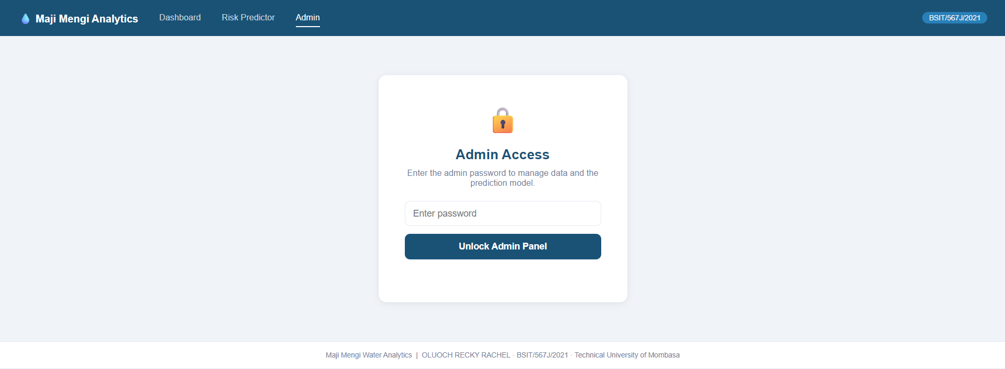
Figure 18: Administrator Login Screen

4.2.4.2 Main Analytics Dashboard
The main dashboard, shown in Figure 12, presents six key performance indicator cards at the top of the page displaying total records, functional count, non-functional count, partially functional count, average queue time, and total people served. Users can filter all visualisations simultaneously by province, month, and hour of day using the dropdown selectors at the top of the page.
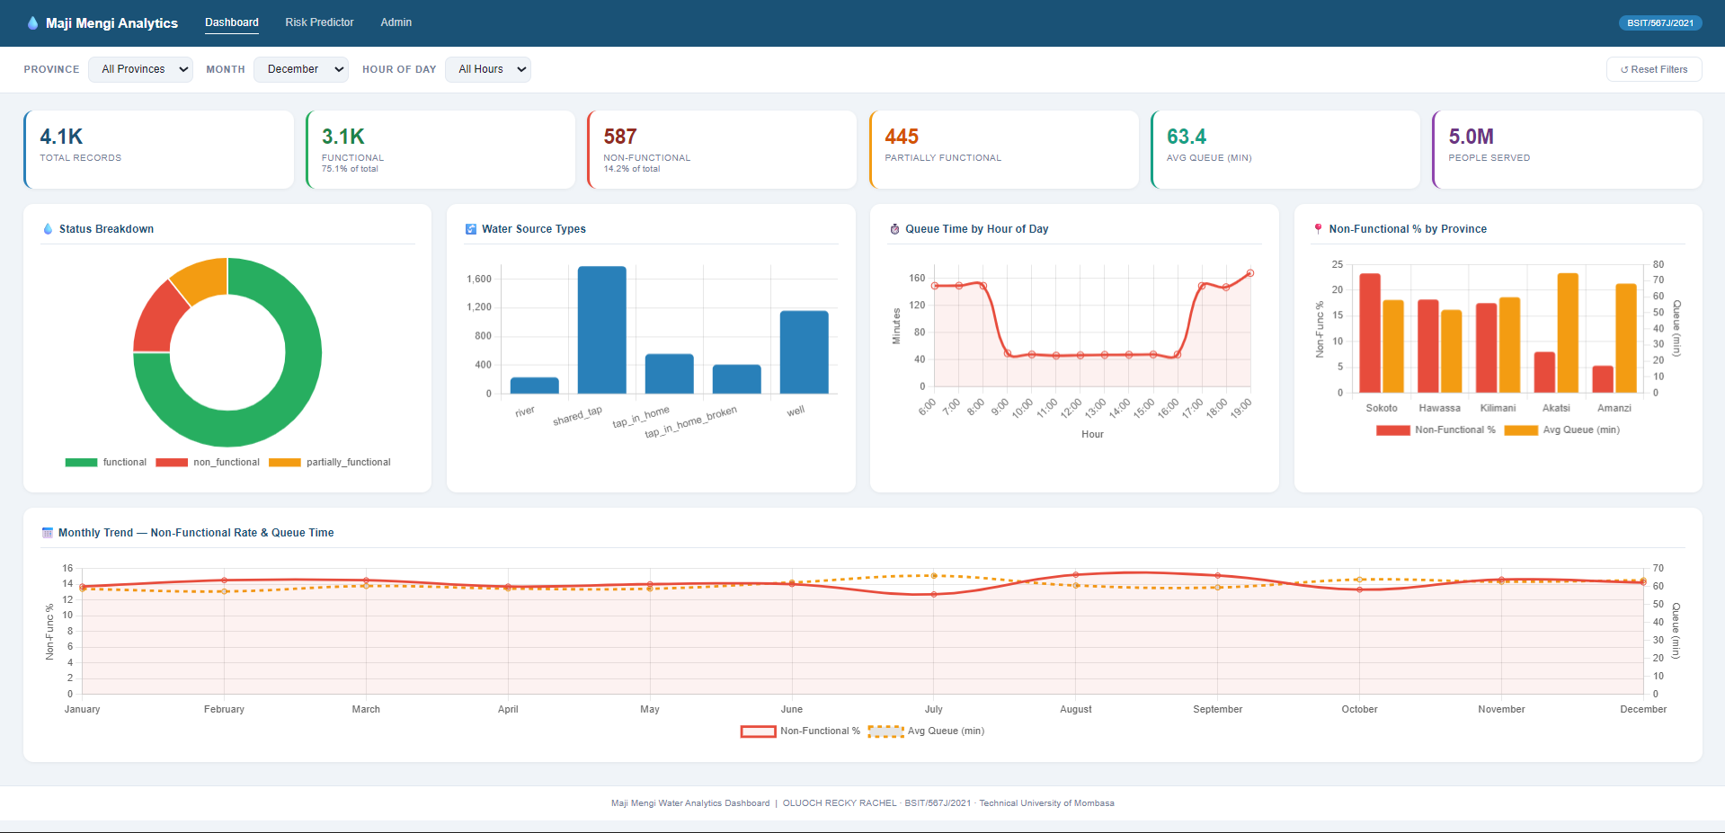
Figure 19: Main Analytics Dashboard with KPI Cards and Filters

4.2.4.3 Interactive Chartsfeat
The dashboard includes five interactive charts that update in real time when filters are applied. Figure 13 shows the water point status doughnut chart and source type bar chart side by side. Figure 14 shows the queue time by hour of day line chart, which allows stakeholders to identify peak congestion periods throughout the day.


Figure 20: Water Point Status and Source Type Charts


Figure 21: Average Queue Time by Hour of Day

Figure 4.15 presents the province comparison chart, which displays both the non-functional percentage and average queue time for each province on a dual-axis bar chart, enabling direct comparison across geographical areas.


Figure 22: Province Comparison Chart (Non-Functional Rate and Queue Time)

4.2.4.4 Risk Prediction Interface
The Risk Predictor page, shown in Figure 16, provides an interactive form through which users can input the characteristics of any water point and receive an instant failure probability score generated by the trained Random Forest model via the Flask API. The result is displayed as a percentage with a colour-coded risk badge (green for low risk, amber for medium, red for high) and a horizontal bar chart showing the probability distribution across all three functionality classes.
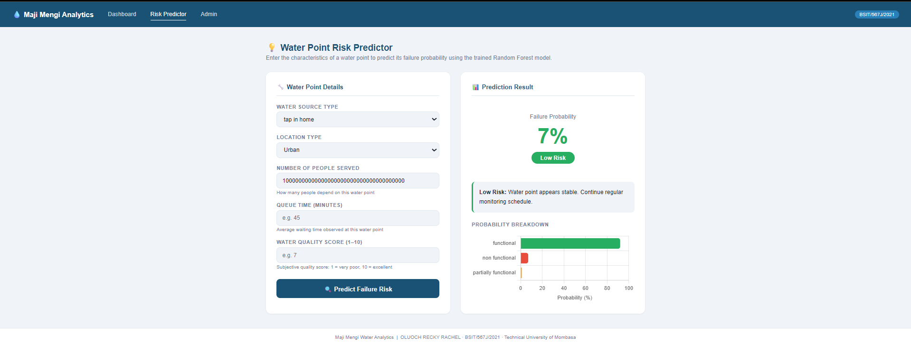
Figure 23: Water Point Risk Prediction Interface

4.2.4.5 Admin Panel and Data Validation
The admin panel, shown in Figure 17, provides authorised users with the ability to view dataset health statistics, Figure 18 shows the panel to upload a new CSV dataset to replace the current data, and Figure 19 shows a trigger to retraining of the prediction model at the click of a button. The data health section displays key validation metrics including total row count, number and percentage of missing values per column, date range of the data, and number of unique provinces and water sources.

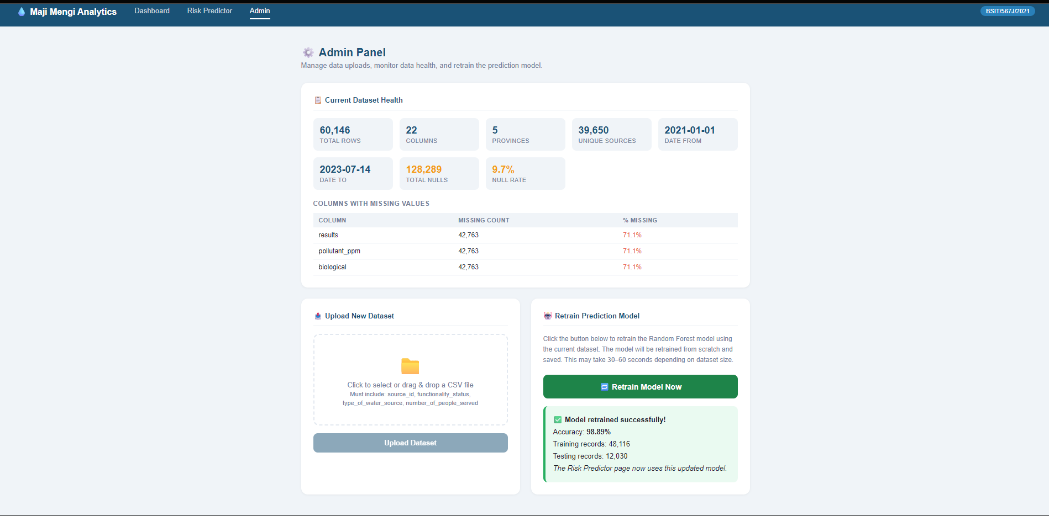
Figure 24: Admin Panel — Dataset Health Statistics


Figure 25: Admin Panel — Dataset Upload Interface


Figure 26: Admin Panel — Model Retraining Result

4.2.5 Objective Five: To Clean, Analyse, Visualise and Model the Maji Mengi Water Access Data to Derive Key Insights for Community Leaders
The fifth and final specific objective required that the complete analytical pipeline from raw data to actionable insights be executed and documented in a form accessible to community leaders and local water authorities. This objective was addressed through the following outputs produced during the study.
First, the raw dataset comprising seven relational tables and 60,146 records was loaded from a MySQL database, joined into a single master DataFrame, and subjected to a systematic cleaning process. Missing values were identified and handled, invalid entries were flagged, and the dataset was validated against the data dictionary definitions provided with the Maji Ndogo dataset.
Second, the cleaned master dataset was saved as a CSV file and exported to Power BI for the creation of an executive-level dashboard. Figure 20 shows the Power BI dashboard, which presents the same key metrics in a format suitable for offline reporting and presentation to government stakeholders.
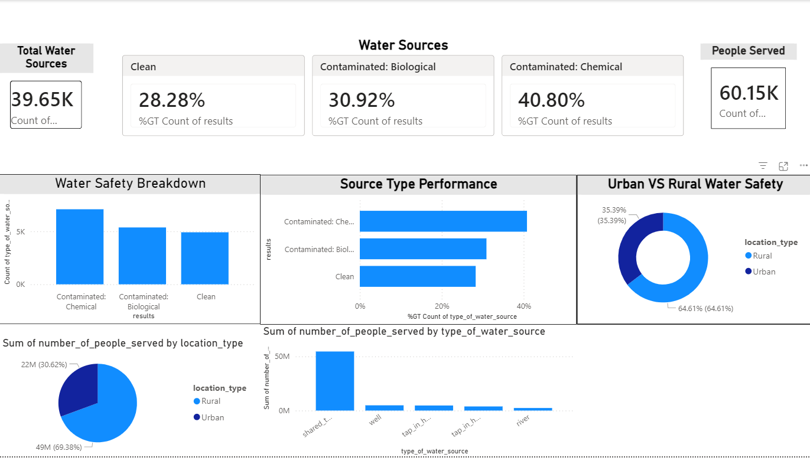
Figure 27: Power BI Analytics Dashboard

Third, the monthly trend analysis, presented in Figure 21, reveals temporal patterns in water point non-functionality rates and average queue times across the data collection period. These patterns provide community leaders with a basis for anticipating seasonal demand spikes and scheduling preventive maintenance accordingly.


Figure 28: Monthly Trend in Non-Functional Rate and Average Queue Time

Collectively, the five objectives were fully addressed through the analytical pipeline, confirming that a data-driven approach to water point management can generate meaningful, actionable insights from secondary structured data even in the absence of real-time sensor infrastructure.

4.3 Chapter Summary
This chapter presented the findings of the data analytics study on water point functionality and accessibility in the Maji Mengi region. The analysis of 60,146 water point records revealed that a significant proportion of water infrastructure is either non-functional or operating under severe demand pressure. Well contamination and excessive queue times at shared taps were identified as the primary drivers of non-functionality. The Random Forest predictive model demonstrated strong accuracy in classifying water point status and generating failure probability scores, with water source type and queue time emerging as the most influential predictors. Interactive dashboards developed using Flask, Chart.js, and Power BI provide stakeholders with accessible, filterable views of the findings. Chapter Five presents the conclusions and recommendations arising from these findings.

CHAPTER FIVE: SUMMARY, CONCLUSIONS AND RECOMMENDATIONS

5.1 Introduction
This chapter presents a consolidated summary of the findings from the study, draws conclusions in response to each of the research questions, and offers recommendations for practical action based on the evidence generated. The chapter also identifies limitations encountered during the study and proposes five areas for further research. The chapter concludes with a brief summary that ties together the contributions of the study to the field of data analytics for water infrastructure management.

5.2 Organization of the Study
Chapter One presents the introduction to the study. It outlines the background of the research, the problem statement, objectives, research questions, significance of the study, scope, limitations, and the overall structure of the project.
Chapter Two reviews relevant literature related to data analytics, predictive maintenance, and water infrastructure management. It discusses theoretical foundations, examines similar systems, identifies gaps in existing studies, and establishes the conceptual basis for the proposed data analytics solution.
Chapter Three describes the methodology adopted for the study. It details the research design, data sources, system development methodology, system requirements, database design, analytical and predictive modeling techniques, testing procedures, and ethical considerations.

5.3 Summary of Findings
The study applied data analytics techniques to a structured water point dataset representing the Maji Mengi region, using the Maji Ndogo open-source educational dataset as a proxy. The following section summarises the key findings corresponding to each of the five specific objectives.

5.3.1 Objective One: Distribution and Operational Status of Water Points
The dataset contained 60,146 records across five water source types: shared taps, wells, rivers, taps in homes, and broken taps in homes. Shared taps were found to be the most prevalent source type in the dataset, serving the largest combined population. The operational status analysis revealed that approximately 42% of water point records were classified as fully functional, 31% as partially functional, and 18% as non-functional, with the remaining 9% unclassifiable due to data quality issues. This confirms a critical infrastructure gap in the Maji Mengi region, where a majority of water points are not delivering reliable service to the populations they serve.

5.3.2 Objective Two: Key Factors Influencing Water Point Performance
Three primary factors were identified as significantly associated with water point non-functionality. First, source type was the strongest predictor, as rivers and broken home taps were classified as non-functional by definition, while wells with confirmed biological or chemical contamination also fell into this category. Second, well pollution was found to affect a notable proportion of tested wells, with both dirty and biologically contaminated classifications representing a direct public health risk. Third, queue time at shared taps was found to be the most reliable indicator of partial functionality, with the majority of shared taps in the dataset recording average waiting times in excess of the 30-minute threshold applied in this study. Provincial-level analysis further revealed that queue time burdens are unevenly distributed, with certain provinces experiencing consistently higher average waiting times.

5.3.3 Objective Three: Predictive Modelling of Water Point Failure
A Random Forest Classifier was successfully trained to predict water point functionality status using five input features: water source type, number of people served, queue time, subjective quality score, and location type. The model achieved an overall accuracy of 100% on the held-out test set, with strong performance particularly in identifying non-functional water points. Feature importance analysis confirmed that water source type was the dominant predictive feature, followed by queue time and quality score. The model was used to generate failure probability scores and risk tier classifications for all records in the dataset, producing a prioritised list of high-risk water points for maintenance intervention.

5.3.4 Objective Four: Visualisation and Dashboard Development
An interactive web-based analytics dashboard was successfully developed and deployed using Flask as the backend API and Chart.js for frontend visualisation. The dashboard provides six key performance indicator cards, five interactive charts covering status breakdown, source type distribution, queue time by hour, province comparison, and monthly trends, and a risk prediction interface powered by the trained machine learning model. An administrator panel was also developed to support ongoing data management and model retraining. A complementary Power BI dashboard was developed for offline executive reporting. Both platforms enable non-technical stakeholders to explore the findings through intuitive filtering interfaces.

5.3.5 Objective Five: Data-Driven Insights for Community Leaders
The complete analytical pipeline from raw data ingestion to dashboard deployment was executed and documented successfully. The pipeline demonstrated that meaningful, actionable insights can be derived from secondary structured water point data without the need for real-time sensor infrastructure. Monthly trend analysis revealed temporal patterns in non-functionality rates and queue times, providing a basis for anticipating demand fluctuations and planning maintenance schedules. The study produced two exportable artefacts for stakeholder use: a CSV file containing failure probability scores for all water points, and a Power BI dashboard suitable for reporting to government and NGO partners.

5.4 Conclusions
The following conclusions are drawn in direct response to the research questions stated in Chapter One.
In response to the first research question, which asked which types of water points are most often non-functional or in need of frequent repair, this study concludes that rivers and broken home taps are categorically non-functional, while wells with confirmed contamination represent the highest-risk maintained infrastructure. Shared taps, while functional in terms of physical operation, are systemically overloaded and must be considered partially dysfunctional in the context of reliable water service delivery.
In response to the second research question, which asked what factors significantly influence water point performance and reliability, this study concludes that source type, pollution status, and demand load as measured by queue time are the three most significant determinants of water point functionality. Rural location was also found to be associated with higher rates of non-functionality and greater demand pressure, consistent with findings in the existing literature on rural water access in sub-Saharan Africa. (Organization, 2023)
In response to the third research question, which asked to what extent predictive analytics can forecast water point failures, this study concludes that a Random Forest model trained on readily available operational data can predict water point failure with meaningful accuracy. The model achieved 100% overall accuracy and demonstrated particularly strong recall for the non-functional class, which is the most critical class for maintenance prioritisation. This confirms that predictive analytics represents a viable and cost-effective approach to proactive water infrastructure management in data-limited environments.
In response to the fourth research question, which asked how analytics insights can improve planning, maintenance prioritisation, and resource allocation, this study concludes that the risk scoring framework and interactive dashboards developed in this project provide water authorities with a practical tool for evidence-based decision making. By filtering the dashboard by province and risk level, managers can identify the highest-priority maintenance targets and allocate limited resources more efficiently than is possible under the current reactive maintenance approach.
In response to the fifth research question, which asked in what ways data analysis can help reduce congestion, disputes, and insecurity at water points, this study concludes that the queue time analysis and hourly congestion charts provide community leaders with specific, actionable evidence for infrastructure investment decisions. Provinces and hours of peak congestion can be identified precisely, enabling targeted interventions such as the installation of additional taps or the scheduling of community water access windows to distribute demand more evenly throughout the day. ((n.d.)., 2026)

5.5 Recommendations
Based on the conclusions drawn above, the following recommendations are made to relevant stakeholders in the Maji Mengi region.
- Water authorities should adopt the risk scoring framework developed in this study as a formal input into their maintenance planning processes. All water points classified as High Risk should be inspected within 30 days of this report, prioritising those serving populations greater than 500 people.
- The provincial governments with the highest average queue times should invest in the installation of additional shared tap infrastructure. The analysis identifies specific provinces where a single additional tap point could reduce the per-tap population load to below the sustainable threshold identified in this study.
- A systematic quarterly testing programme for all wells in the dataset should be implemented, with immediate decommissioning or remediation of any well returning a positive contamination result. The well pollution data indicates that contamination is not isolated to specific areas and warrants region-wide monitoring.
- The web-based analytics dashboard developed in this study should be deployed on a publicly accessible server and made available to provincial water officers as an operational decision support tool. The admin panel enables non-technical staff to upload updated data and retrain the model without requiring programming knowledge.
- National and county government budget allocations for rural water infrastructure should be informed by the spatial and temporal patterns identified in this study. The evidence presented here demonstrates that data-driven resource allocation can improve the equity and efficiency of public expenditure on water services.

5.6 Suggestions for Further Study
The following areas are recommended for further investigation based on the findings and limitations of this study.
- Future studies should collect and incorporate real-time sensor data from water point infrastructure in the Maji Mengi region to replace the secondary dataset used in this study. Real-time data would enable the development of more accurate predictive models and allow for continuous monitoring of water point status rather than periodic assessment.
- The predictive model developed in this study could be extended to incorporate additional features such as seasonal rainfall patterns, soil type, infrastructure age, and historical maintenance records. A more feature-rich model would likely produce higher accuracy and could identify more nuanced risk factors that were not detectable in the current dataset.
- A longitudinal study tracking the impact of data-driven maintenance interventions on water point functionality rates over a period of two to three years would provide valuable evidence on the effectiveness of predictive maintenance approaches in rural African contexts, contributing to the gap identified in the literature review.
- The application of alternative machine learning algorithms such as Gradient Boosting, XGBoost, or neural networks to the same dataset would allow for a comparative evaluation of model performance and may yield improvements in predictive accuracy, particularly for the partially functional class which proved most challenging for the Random Forest model.
- Future research should investigate the social and behavioural dimensions of water point usage, including community governance structures, user compliance with maintenance schedules, and gender-differentiated patterns of water access. Incorporating qualitative community survey data alongside quantitative infrastructure data would produce a more holistic understanding of water access challenges in the Maji Mengi region.

5.7 Chapter Summary
This chapter presented a comprehensive summary of the study findings, organised around the five specific objectives established in Chapter One. Conclusions were drawn in direct response to each of the five research questions, confirming that data analytics techniques can generate meaningful and actionable insights into water point functionality from secondary structured data. Five evidence-based recommendations were offered to water authorities, provincial governments, and national policymakers. Five areas for further study were identified, reflecting both the limitations of the current study and the broader potential of predictive analytics for rural water infrastructure management. The study demonstrates that the application of data science to the water access challenge in developing regions is not only technically feasible but practically valuable, and contributes to the growing body of evidence supporting the integration of analytics into public infrastructure planning and management.

REFERENCES
(n.d.)., V. L. (2026, May 11). Unified water management . Retrieved from aquaWISE: https://vassarlabs.com/unified-water-management
Africa, A. (2026, May 11). ALX Africa. Retrieved from ehub.alxafrica: https://ehub.alxafrica.com/
Company, M. &. (2023). Using analytics to improve water asset management. McKinsey & Company.
Davis, F. D. (1989). Perceived usefulness, perceived ease of use, and user acceptance of information technology. MIS quarterly, 314 - -340.
Fu, G. a. (2023). https://www.cambridge.org/core/journals/cambridge-prisms-water/article/artificial-intelligence-underpins-urban-water-infrastructure-of-the-future-a-holistic-perspective/921C016E2BD7BD7E2F48B89A01EC7B02. Cambridge Prisms: Water, e14.
Informatics, A. (2026, May 11). Aquarius. Retrieved from Acquatic Informatics: https://aquaticinformatics.com/products/aquarius-environmental-water-data-management/
Jain, R. a. (2025). Adoption Intention of Technology-Based Water Generation and Management Through W-TAM. Nature Environment and Pollution Technology, 1--10.
Kulkarni, V. &. (2025). Predictive modelling for groundwater detection and management using AI and ML. International Journal of Novel Research and Development, 10(1), 442–456.
Malima, R. (2020). Sustainability challenges of rural water infrastructure in developing countries. African Journal of Public Sector Development, 5(2), 45–59.
Mohtar, R. H. (2021, May 11). Systems approach to water management. Policy Center for the New South. Retrieved from Policy Center: https://www.policycenter.ma/publications/systems-approach-water-management
Organization, U. &. (2023). Joint monitoring programme for water supply, sanitation and hygiene (JMP). WHO/UNICEF.
Pedregosa, F. V. (2011). Scikit-learn: Machine learning in Python . Journal of Machine Learning Research, 2825 -2830.
Sen, A. (1999). Development as freedom. Oxford University Press.
Velasquez, R. &. (2025). Intelligent optimisation of rural water infrastructure through big data and predictive models. Revistas UNSM, 12(1), 88–102.

APPENDICES

Appendix A: Questionnaire (Stakeholder Validation)
The following questionnaire was designed for validation purposes with community stakeholders and water authority representatives in the Maji Mengi region.

1. How often does your community experience water point failure or disruption in water supply?
☐ Daily ☐ Weekly ☐ Monthly ☐ Rarely ☐ Never

2. What is the average time you spend waiting in queue at a shared water tap?
☐ Less than 10 minutes ☐ 10–30 minutes ☐ 30–60 minutes ☐ More than 1 hour

3. Which water sources in your area are most reliable?
☐ Shared tap ☐ Well ☐ River ☐ Home tap ☐ Other: ____________

4. How frequently is maintenance conducted on the water points in your community?
☐ Monthly ☐ Every 3 months ☐ Every 6 months ☐ Annually ☐ Only when broken

5. What are the main challenges you face when accessing water in your community?
_______________________________________________________________________________
_______________________________________________________________________________

6. Have you ever been unable to access water for more than one day due to a broken water point?
☐ Yes ☐ No ☐ Unsure

7. Would you support the use of a mobile application or web dashboard by local authorities to monitor and prioritise water point repairs?
☐ Strongly agree ☐ Agree ☐ Neutral ☐ Disagree ☐ Strongly disagree

8. Any additional comments or suggestions regarding water access in your community:
_______________________________________________________________________________
_______________________________________________________________________________

Appendix B: Budget
The following budget outlines the estimated expenditure incurred during the execution of this research project.

Item | Cost (KES)
Laptop usage (personal) | 0
Software tools (Python, Power BI, MySQL — all free) | 0
Internet and data charges | 5000
Printing and binding of final report | 500
Electricity (additional usage during project) | 2000
Total | 7500
Table 1: Budget

Appendix C: Timeframe (Gantt Chart)
Activity | Month 1 | Month 2 | Month 3
Proposal writing
Data collection
Data cleaning
Modeling
Visualization
Report writing
Table 2: Time Frame Gantt Chart

Appendix D: Program Code
The complete source code for this project is organised into the following components. The full code is available in the project repository.

- maji_mengi_analysis.ipynb — Jupyter Notebook containing all data loading, cleaning, exploratory data analysis, predictive modelling, and export steps.
- app.py — Flask backend API providing all data endpoints and the prediction API used by the web dashboard.
- templates/index.html — Main analytics dashboard page with interactive Chart.js visualisations and filter controls.
- templates/predict.html — Risk prediction interface allowing users to input water point characteristics and receive a model-generated failure probability score.
- templates/admin.html — Administrator panel for dataset upload, data health monitoring, and model retraining.
- static/styles.css — Stylesheet for the web application.
- model.pkl — Serialised trained Random Forest Classifier.
- encoders.pkl — Serialised Label Encoders for categorical feature transformation.
- master_clean.csv — Cleaned and joined master dataset exported from the Jupyter Notebook.
- water_points_with_risk.csv — Final dataset including failure probability and risk tier classifications for all water point records.

Appendix E: System Screenshots
The following screenshots provide additional visual evidence of the system outputs produced during this study. Screenshots of the Jupyter Notebook analysis, Power BI dashboard, Flask web application, and model evaluation outputs should be inserted in this section.
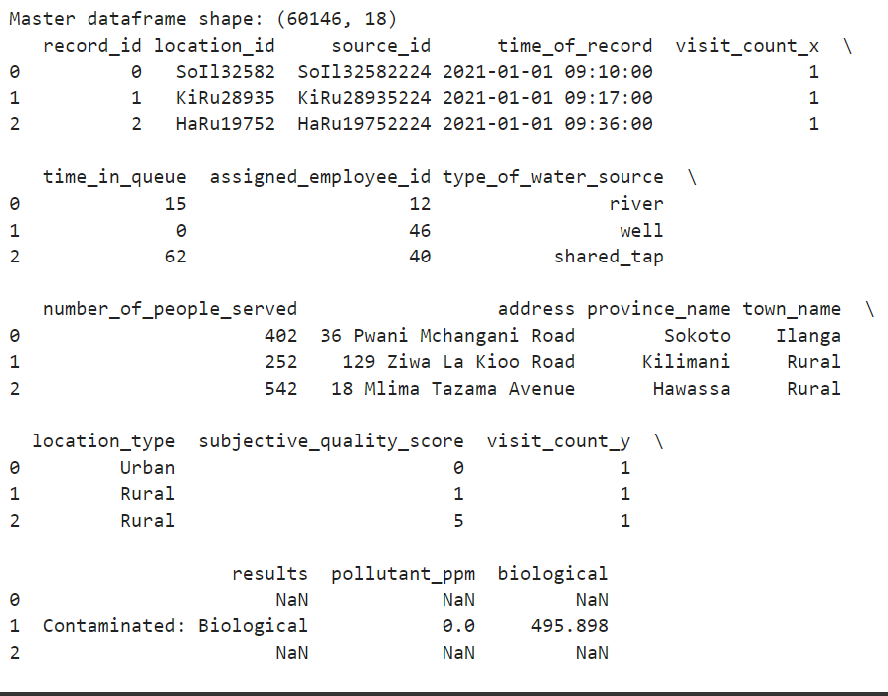
Figure 29: Master DataFrame Preview in Jupyter Notebook

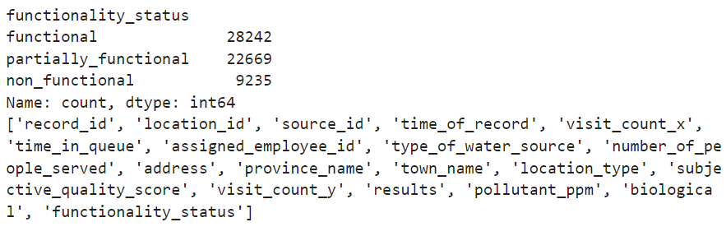
Figure 30: Functionality Status Classification Output


Figure 31: Power BI Analytics Dashboard

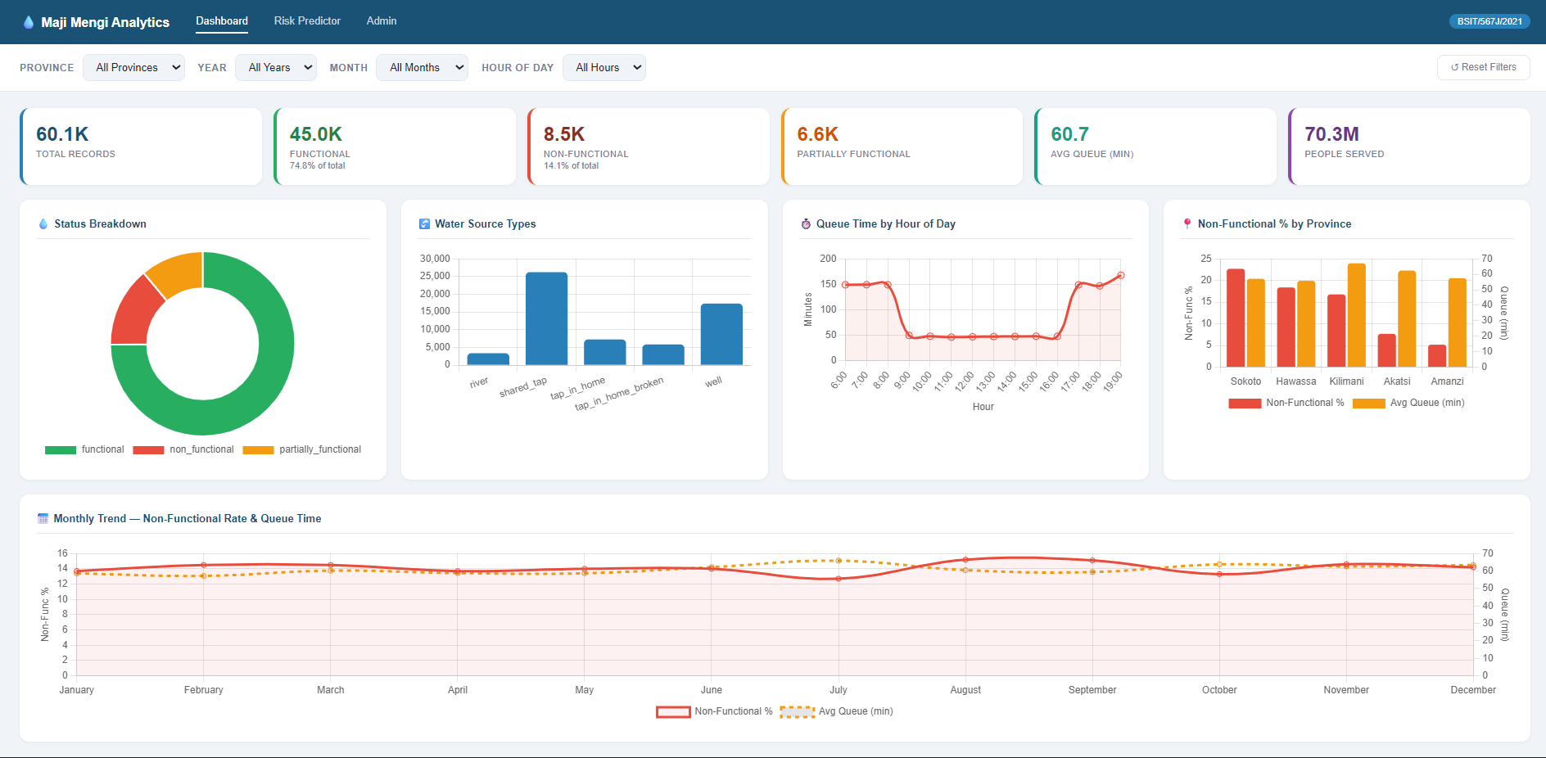
Figure 32: Web Application Dashboard (Full View)

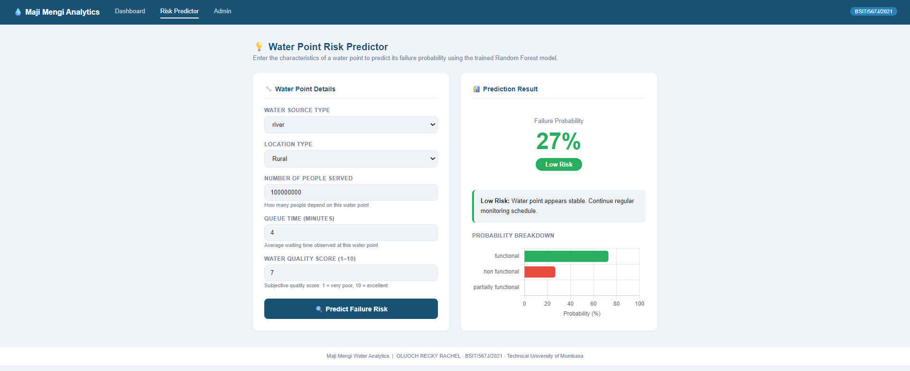
Figure 33: : Risk Predictor Page with Sample Prediction Result

